10.97: From Eq. (10.36),

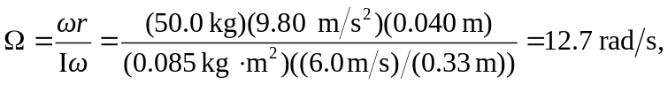

or 13 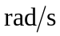to two figures, which is quite large.

